15.18: a) The tension at the bottom of the rope is due to the weight of the load, and the speed is the same 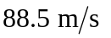as found in Example 15.4 b) The tension at the middle of the rope is (21.0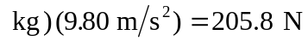(keeping an extra figure) and the speed of the rope is 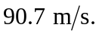 c) The tension at the top of the rope is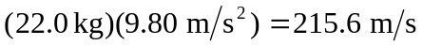 and the speed is 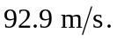 (See Challenge Problem (15.80) for the effects of varying tension on the time it takes to send signals.)

